# Description: MCj04348420000[1]

Inside This Issue

1 President’s Message

2 Red Roses & Congratulations

2 November Snapshots

3 Minutes

4 Minutes

5 Upcoming Events

5 Dec. – Jan. Birthdays

5 Collect

5 January Hostesses

5 Elevator Speech

6 State Theme for the 2015- 2017 Biennium

6 Graphics Citations

***Mission Statement****:*

*The Delta Kappa Gamma Society International promotes professional and personal growth of women educators and excellence in education*

# January Meeting Location

Please note: The next meeting will be January 12 at **Pine Ridge Elementary Library**

**Special Guest: Randy Rae and Debbie, Master Gardeners**

**4:30 PM: Refreshments 4:45 PM: Meeting**

Program Title: “Container Gardening with Master Gardeners, Randy Rae and Debbie”

Theme: International Purpose- To unite women educators of the world in a genuine spiritual fellowship

State Theme: Achievement: Health: To encourage members to practice healthy lifestyles, which promote healthier chapters

**Don’t forget** to use our phone tree for reminding each member about upcoming meetings. Then let’s carpool with other members.

President’s Small Talk Message……..Happy 2016 Sisters!

WELCOME to the New Year and the advancement of our chapter sisterhood!

The end of one year and the beginning of a new year often motivates us to inventory who we are, how we’re doing, and what we could do better next year.. Before starting to address change though, I want to urge you to take a deep breath and a little time to celebrate our achievements over the past several months. Our sisterhood has been strong and meaningful and I believe we can definitely learn new ways to deal with challenges that will make our chapter even more productive and more fulfilling for all.

Last week, in taking down Christmas at my house, I began to remove ornaments and the decorations from the tree. There, deep behind the tree and nestled in the corner, I noticed lying on the floor was a soft blanket and a pair of small brand new tennis shoes. I took a phone picture and forwarded it to Abby’s mom and dad saying, “Look what I found behind the Christmas tree!” The find was a good one for me because it brought back the laughter and the fun lingering in my mind after all was said and done. This is the way I feel about our experience together as Delta Epsilon sisters. When all is said and done, how we made one another feel during our experiences together will be the lingering thoughts in our mind and hearts. Looking forward to next Tuesday as we come together to record more lifetime memories. Sherry

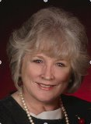

Delta Epsilon, Chapter No. 101

# PRESIDENT’S MESSAGE

By Sherry Kenner

The Delta Kappa Gamma Society International Texas State Organization

Delta Epsilon: Serving Polk, Tyler and San Jacinto Counties Area 2

Cheryl Timko, Editor cjtimko@hotmail.com

January 2016

Volume 66 Issue 4

Chalk Duster

# Red Roses and Congratulations:

# 

A very special thank you goes to Elena Ivanova, Area 2 Coordinator, for presenting the program, *Education in Russia*, and Carol Shields, Director of the Whitmeyer Library and to Sherry Kenner for preparing the fabulous meal.

Congratulations go to Lisa Collins for the Early Bird Award for our Chapter Yearbook.

**November Snapshots**

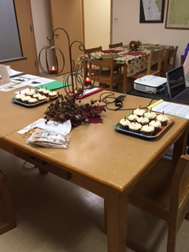 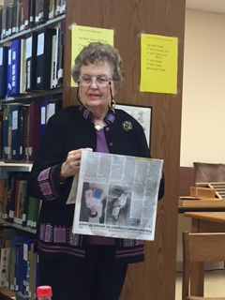 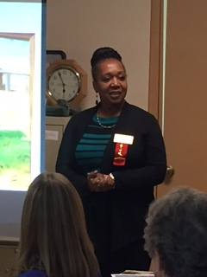

Lisa Collins informing the chapter of winning the Early Bird Award for our Yearbook.

Patricia Prichard Alexander, daughter of Ruth Pritchard, longtime Delta Kappa Gamma member, reading an article about her mother from the Polk County Enterprise

Delta Kappa Gamma Birthday Celebration

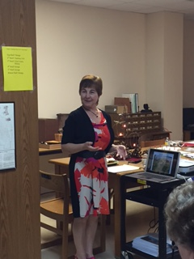 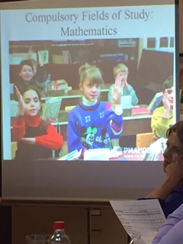 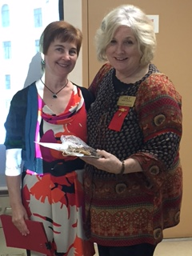

Sherry Kenner, Delta Epsilon President, with Elena Ivanova.

Elena Ivanova, Area 2 Coordinator, presenting the program, Education in Russia.

# 

**Delta Kappa Gamma Society International**

**Delta Epsilon Chapter – Regular Meeting**

**Minutes of November 12, 2015**

**Whitmeyer Library, Heritage Village – Woodville, Texas**

Sherry Kenner introduced Dr. Elena Ivanova, Area II Coordinator and Carol Shields, director of the Whitmeyer Library, Heritage Village, Woodville, Texas and one responsible for our meeting place. She then asked Sharon Anderson to introduce her guest, Patricia Prichard Alexander the daughter of Ruth Prichard, a past president of Delta Epsilon.

Melinda Stryker then gave the invocation in honor of our veterans. She read the Veteran Prayer. The members then ate a deliciously prepared meal by Sherry Kenner and her husband. It consisted of baked potato and BBQ beef.

Sherry then called the business meeting to order. She reminded us to sign in, “stuff the pig,” buy a chance to win the stained glass heart of roses, and pick up our yearbook. She also explained that there were 3” x5” cards in Flat Annie’s lap that we could use to recommend new members. She asked that we place the name, phone number, address, and position in education on the card. She would then visit with those presented and then send out invitations in the month of January. Lisa Collins was kind enough to prepare the yearbooks and Kathy Weaver printed and compiled them. Lisa told us that we were awarded the early bird award for our yearbook.

Kathy Weaver then gave the financial report. It was reported that we have a balance of $2,978.68 in a CD account, $2,496.60 in a Savings Account, $2,313.11 in Checking Account, and $25.00 in First State Bank of Livingston.

Because Annette Adkins was absent, Sherry Kenner presented the minutes and asked Charlotte Hartley to take the minutes of the meeting. Minutes were accepted as written.

Sharon Anderson then presented Patricia Prichard Alexander who read a news article about Ruth Prichard. Ruth was our president in the biennium 1974-1976. She began teaching senior English at the age of 19 in Livingston. She was fortunate to receive a job because at that time it had been decided that only men could teach. Fortunately the school board was unable to find a male English teacher so hired Ruth. She was forced to retire at 65 because

at that time it was the rule of the Texas Education Agency. Because her husband, a judge, died she finish out his term and became re-elected in Livingston, Texas. Not only was she president of Delta Epsilon, but served as the music director for Alpha State.

Sherry Kenner then turned our meeting over to Dr. Elena Ivanova who presented our program. Being a citizen of Russia she was able to give us a picture of education in Russia. Through a power point presentation we learned that education for a child was held in one building that housed grades 1st through 8th grades or 1st through 11th grades with two classes of each grade level. Foreign languages began in 5th -11th grades. Some schools had a submersion English class from 2nd through 11th grades. At the close of her presentation, Sherry presented her a token of thanks.

Sherry and Kathy then lit the candles on each of the cupcakes and we sang Happy Birthday to celebrate the 66th birthday. Dr. Elena read the words to our Delta Kappa Gamma Song and we sang the chorus. It was announced that our next meeting would be held in Livingston. The program would be on container gardening. Melinda Stryker won the door prize and the meeting was adjourned.

Respectively submitted,

Charlotte Hartley

**Upcoming Events…..** C:\Documents and Settings\acollins\My Documents\My Pictures\Microsoft Clip Organizer\j0359575.wmf

**Mark your Calendar**

* Feb. 1

1. Chapter Necrology Report
2. Chapter Biennial Reports
3. TSO Achievement Award Nomination
4. Golden Rose Award Nomination
5. International Scholarship Appication
6. Nominate TSO Honorary Members
7. International Cornetet Award for Professional Development
8. Submissions for *Lone Star News*
9. TSO Scholarship Applications
10. Mini-Grant Application
11. Convention Breakout Session Proposal
12. State Committee Reports
13. 2016-2018 Chapter Officer Names

* February 16

Contributions to TSO Funds



December & January Birthdays

* Sharon Anderson Dec. 18
* Janel Sewell Dec. 25
* Kathy Weaver Jan. 6
* Pam Monk Jan.7
* Sherry Kenner Jan. 29
* Melinda Stryker Jan. 31

January Hostesses

* Frances Camp
* Alvene Gallowar
* Joanne Westmoreland

Collect

Cheryl Timko

Elevator Speech

The heart of any organization is membership. There is an anonymous quote that states that people aren’t asked to join an organization, they are asked to join people. At our last meeting, two names of potential members were given to me. Our meeting on Tuesday of next week would be a great meeting to invite potential members. Please make membership a top consideration as we move into the next few months.

**“The Heart of the Society is its Members”**

The goals of the biennium are taken from the word Heart:

H – **Health**: to encourage members to practice healthy lifestyles, which promote healthier chapters

E – **Education**: to educate members about the importance of membership and encourage them to make an impact on their communities and the world

A – **Achievement**: to achieve our goals as leaders in our chapters and recognize our accomplishments as key women educators

R – **Reflection**: to reflect on our heritage as we advance the Society

T – **Teamwork**: to work as members of a team to strengthen involvement in all levels of the Society.

Graphics Citation

Red Roses, Pencil and Pad, and Birthday Cake

[http://office.microsoft.com/en-us/image](%20http:/office.microsoft.com/en-us/image)

**Society Vision Statement:** *Leading women educators impacting education worldwide.*

*n worldwide.*

#### Delta Epsilon Chapter

Serving Polk, Tyler and San Jacinto Counties

Area 2—Chapter No. 101