# Description: MCj04348420000[1]

Inside This Issue

1 Meeting Invitation

2 Red Roses & Congratulations

2 January Snapshot

3 Minutes

4 Minutes

5 Upcoming Events

5 February Birthdays

5 Collect

5 February Hostesses

5 Elevator Speech

6 State Theme for the 2015- 2017 Biennium

6 Graphics Citations

***Mission Statement****:*

*The Delta Kappa Gamma Society International promotes professional and personal growth of women educators and excellence in education*



Delta Epsilon, Chapter No. 101

# PRESIDENT’S MESSAGE

By Sherry Kenner

The Delta Kappa Gamma Society International Texas State Organization

Delta Epsilon: Serving Polk, Tyler and San Jacinto Counties Area 2

Cheryl Timko, Editor cjtimko@hotmail.com

February 2016

Volume 66 Issue 5

Chalk Duster

# Red Roses and Congratulations:

# 

A very special thank you goes to Susan Moran for presenting the program, *Texas* *Wildflowers* and to our hostesses Frances Camp, Alvene Galloway and Joanne Westmoreland.

Congratulations go to Kathy Weaver for winning the door prize.

**January Snapshot**

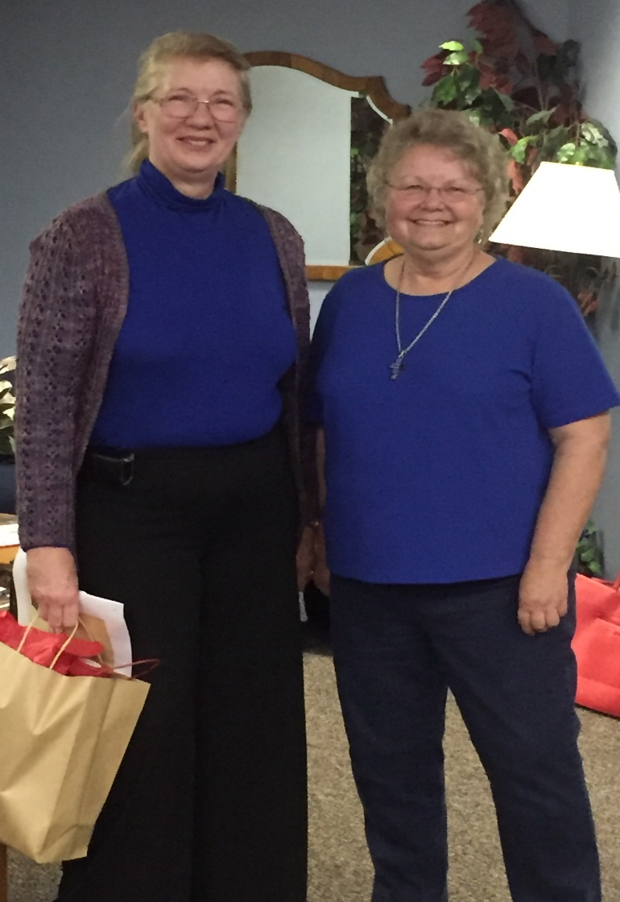

Susan Moran with Charlotte Hartley. Susan presented the program,

*Texas Wildflowers*

**Delta Kappa Gamma Society International**

**Delta Epsilon Chapter – Regular Meeting**

**Minutes of January 12, 2016**

**Pine Ridge Elementary School Library – Livingston**

The regular meeting of Delta Epsilon Chapter of the Delta Kappa Gamma Society International was called to order by our president, Sherry Kenner.

Charlotte Hartley introduced our guest speaker, Susan Muran. Mrs. Muran presented information on TEXAS WILDFLOWERS and low maintenance house plants. Each member learned the scientific names, uses, and duration of the most common Texas Wildflowers. The program was very enlightening and interesting.

Sherry then called the business meeting to order. Due to Annette Adkins being absent, the minutes were taken by Kathy Weaver. The minutes from November 10, 2015 meeting were reviewed and stands approved as written. Kathy Weaver gave the financial report for January. The January financial report included transactions from November and December.

**Committee Reports**:

**Program**: Karen Butler reported on our February 9 meeting. The meeting is to be held in the Home of Becky Harvey. Karen reported February’s meeting will be addressing heirloom reflections and experiences. Each member is to bring an heirloom item to share with the group. Sherry stated the address to Becky’s home will be in the newsletter and in the yearbook under the February meeting details. Sherry also discussed that the Grant-in-Aid Scholarship will be targeted at the February meeting. This year the Grant-in-Aid Scholarship will have a Valentine love theme activity.

**Correspondence:** Correspondence was read by Karen Butler. The chapter received a sweet thank you note from Area II Coordinator, Dr. Elena Ivanova.

**Nominations:** Sherry stated the Nominations Committee will bring a slate of officers to present to the members at the February meeting. She encouraged each member to consider positions and let the committee know their willingness to accept a position. The committee consist of Lisa Collins; chair, Charlotte Hartley, Cheryl Timko.

**Professional Affairs:** Grant-in-Aid Scholarship nominees were brought to the members. They are: Samantha Cain, Livingston, 3rd grade math teacher, Emily Carney, Woodville, elementary inclusion special education teacher, and Candra Huckaby, Woodville, middle school inclusion special education teacher.

Karen Butler made the motion to accept all 3 teachers as a recipient of the scholarship each receiving $100.00. Charlotte Hartley seconded the motion. The motion was approved unanimously by members. The recipients will be invited to the February meeting.

**Membership:** Karen Butler presented Destiny Pennington – Livingston, music instructor, as a candidate for a new member. Karen discussed how actively involved Destiny is in the Livingston ISD.

Sherry Kenner presented Vicki Sheffield - Woodville. There was a discussion about whether Vicki was a transfer into the chapter or a new member. After discussion, members approved Vicki as a transfer. The members, who know Vicki professionally, agree she would be an excellent member. Vicki has shown an interest in joining Delta Epsilon. Sherry stated initiation will be in April.

Kathy Weaver was the door prize winner.

After singing the Delta Kappa Gamma Song, the meeting was adjourned.

Respectively submitted,

Kathy Weaver

**Upcoming Events…..**

* Feb. 1

1. Chapter Necrology Report
2. Chapter Biennial Reports
3. TSO Achievement Award Nomination
4. Golden Rose Award Nomination
5. International Scholarship Appication
6. Nominate TSO Honorary Members
7. International Cornetet Award for Professional Development
8. Submissions for *Lone Star News*
9. TSO Scholarship Applications
10. Mini-Grant Application
11. Convention Breakout Session Proposal
12. State Committee Reports
13. 2016-2018 Chapter Officer Names

* February 16

Contributions to TSO Funds

**Mark your Calendar**

* February 16

Convention Breakout Session Proposal

* March 1

1. Chapter Rules and Bylaws sent to Lynne James
2. Mini-Grant Application
3. TSO Scholarship Application

* March 15

2016-2018 Chapter Officers

* April 1

1. Contributions to TSO Funds
2. ASTEF 2015-2016 Project Information Guide & Application
3. Members in Print Award Application
4. Media Recognition Award Application
5. Submissions for *Lone Star News*
6. Annie Award for Outstanding Program Application



February Birthdays

* Alvene Galloway Feb. 6

February Hostesses

* Karen Butler
* Paula Kimbro
* Lucy Kuntz

Collect

Charlotte Hartley

Elevator Speech

Have you read the article by Allison Venuto*,* “Exploring New TeachingGoals: The 10-2-2” in the current issue of *The Delta Kappa Gamma* Bulletin”? Ms. Venuto discusses this new teaching technique that she has implemented in her classroom.

**“The Heart of the Society is its Members”**

The goals of the biennium are taken from the word Heart:

H – **Health**: to encourage members to practice healthy lifestyles, which promote healthier chapters

E – **Education**: to educate members about the importance of membership and encourage them to make an impact on their communities and the world

A – **Achievement**: to achieve our goals as leaders in our chapters and recognize our accomplishments as key women educators

R – **Reflection**: to reflect on our heritage as we advance the Society

T – **Teamwork**: to work as members of a team to strengthen involvement in all levels of the Society.

Graphics Citation

Red Roses, Pencil and Pad, and Birthday Cake

[http://office.microsoft.com/en-us/image](%20http:/office.microsoft.com/en-us/image)

Invitation Graphic

<http://olddesignshop.com/2012/02/fan-shaped-victorian-calling-card/>

**Society Vision Statement:** *Leading women educators impacting education worldwide.*

*n worldwide.*

#### Delta Epsilon Chapter

Serving Polk, Tyler and San Jacinto Counties

Area 2—Chapter No. 101